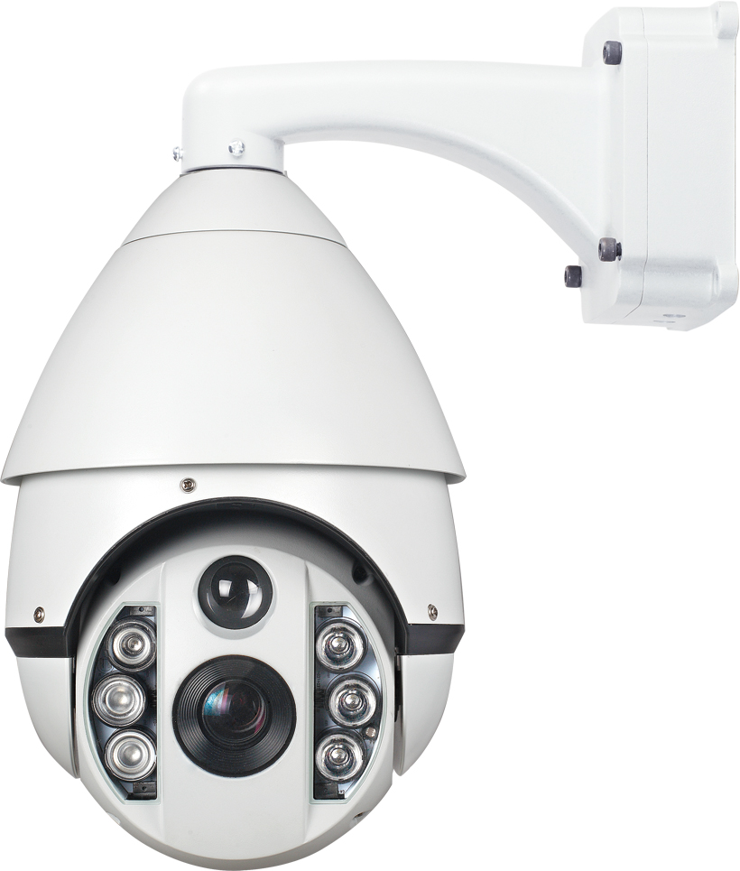
TT-DA91T-SL
Laser High Speed Dome

……………………………………………………………………………………………………

Features
Laser night vision:
- * Adopt Laser light+ Secondary Concentrator Bilens, night vision distance up to 200 meters.
- * According to the zoom, open the laser IR light in sections, night vision effect evenly.
- * With Laser light’s strong ability to penetrate the fog, it solves the problems for the night fog in the outside.

PTZ function
- Alarm(Optional)
- Adaptive PELCO-P/D protocol, Auto detected Baud Rate
- Auto running memory against power outage
- RTC function, call any functions at any time
- 8 privacy masks (need the support of the camera)
- Support 128 preset positions, and support lens preset
- English OSD menu, Short-cut key operation to PTZ functions
- Pan/Tilt speed: 0.08°～240°/S, preset accuracy: <±0.1°
- Soft Address: can modify the 485 address remotely, convenient installation and maintenance
- Compass function,proportional zoom and auto flip function
- Built in double devices for lightning proof and surge proof
- Support multi-protocols: SONY、LG、CNB、HITACHI、SAMSUNG etc.
- Support 4 groups cruise scan,4 group patterns, one scan, and 360°continuous scan and 360°intermittent scan
Standard camera module
* DSP ：SONY EFFIO-E；
* 1/3" SONY CCD；
* 32X, 700TVL, 36X 650TVL, 36X 800TVL
*Focal Length：5.4～97.2mm；
* IR-Cut Switch；
Specifications
Power Supply | Output：DC12V±5%，5A  Input：AC100～240V 50/60Hz
Max. Power | IR off：15W  IR on：35W
Sync system | Internal Sync
Language | English
Pan Speed | 0.08°～240°/S
Tilt Speed | 0.08°～240°/S
Pan Range | 0°～360°(Continuous)
Tilt Range | 0°～90°（180° auto flip）
Preset | 128
Preset Accuracy | <±0.1°
Tour | 4, 27 presets/tour
Pattern | 4
Zone | 1
Protocol | RS485
Communication | PELCO-D/P auto Adaptive
Baud Rate | 2400bps、4800bps、9600bps、19200bps
Address | 1-255
RTC | Set any key at any time
IR Light switch | Default::1~5 times, open the near-distance lights; 6~9 times, open the near-distance and middle-distance lights; after 10 times, turn of f the near-distance lights, open the middle-distance and far-distance lights. (Light open times can be settable, near-distance light close and far-distance light open happen at the same time.
Work Temperature | Indoor：0℃～+50℃；  Outdoor ：-20℃～+50℃(with heater)
Work Humidity | <90%

Size（mm）
